Telecom Customer Churn Analysis and EDA using SQL Server Management Studio
Project Overview
This project analyzes telecom customer churn using SQL Server Management Studio and Microsoft Power BI to identify customer segments with high attrition rates, understand churn patterns, and generate actionable business recommendations for improving customer retention.
The interactive dashboard explores churn across contract types, internet services, payment methods, customer tenure, age groups, gender, states, and churn reasons.

Business Objectives
- Measure total customers, churn count, and overall churn rate.
- Identify customer segments with the highest churn rates.
- Analyze churn patterns by contract type, internet service, and payment method.
- Examine geographic differences in customer attrition.
- Identify the leading reported reasons for customer churn.
- Recommend data-driven strategies to improve retention.

Key Findings
- Overall churn: 1,732 customers churned out of 6,418, resulting in a 27.0% churn rate.
- Contract type: Month-to-month customers recorded the highest churn rate at 46.5%, compared with 11.0% for one-year contracts and 2.7% for two-year contracts.
- Internet service: Fiber-optic customers had a churn rate of 41.1%, the highest among the displayed service categories.
- Payment method: Mailed-check customers showed a churn rate of 37.8%.
- Geographic analysis: Jammu & Kashmir had the highest churn rate among the five displayed states, at 57.2%.
- Churn reasons: Competitor-related issues represented the largest reported churn category, with 761 cases.
- Tenure analysis: Churn rates remained relatively consistent across the displayed tenure groups, ranging from 26.1% to 27.5%.

Business Recommendations
- Introduce targeted retention offers for month-to-month customers.
- Investigate fiber-optic service quality, pricing, and customer experience.
- Analyze regional churn drivers and prioritize high-churn markets.
- Encourage convenient digital payment options where appropriate.
- Strengthen competitor monitoring and customer win-back campaigns.
- Track retention performance through regular KPI reviews.

Tools & Skills
- Microsoft Power BI and SQL Server Management Studio
- Data Cleaning and handling NULL using SSMS
- Data Visualization and Dashboard Development
- DAX Measures and KPI Reporting
- Customer Segmentation
- Exploratory Data Analysis
- Business Intelligence
- Data-Driven Decision-Making

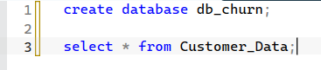

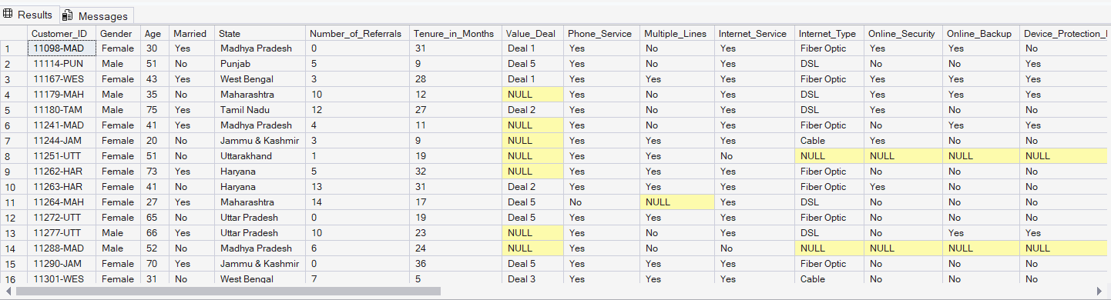

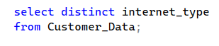
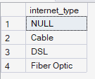

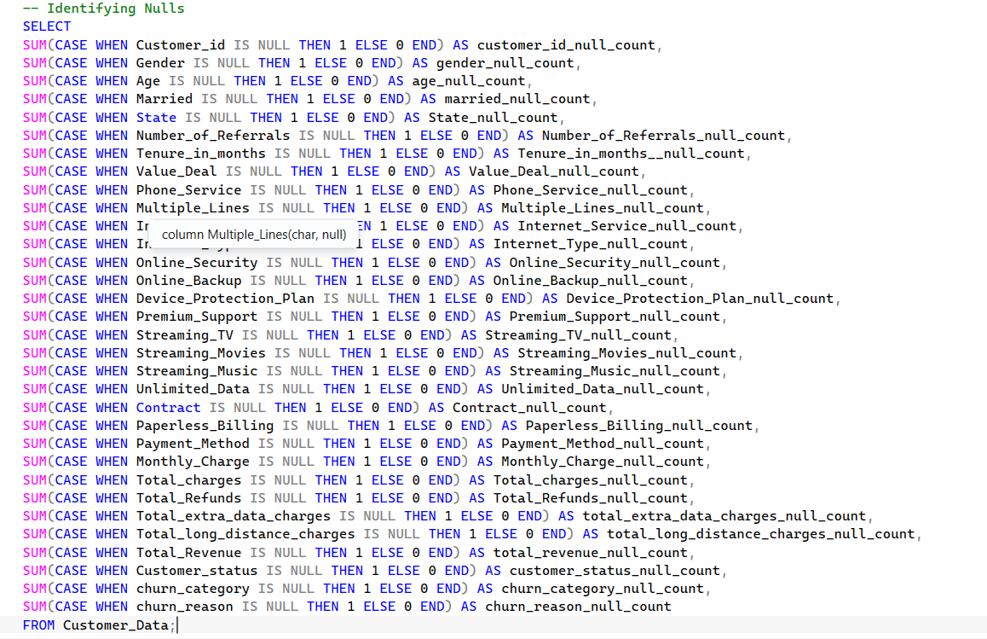

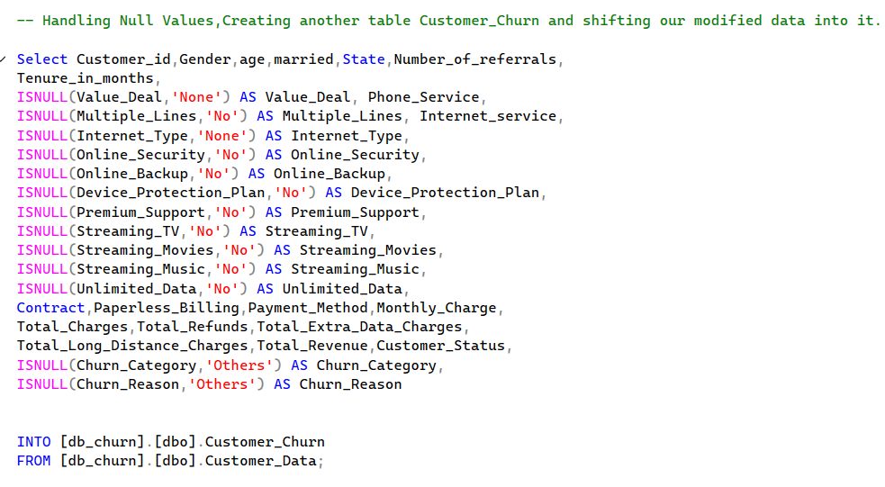

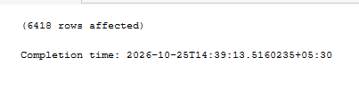

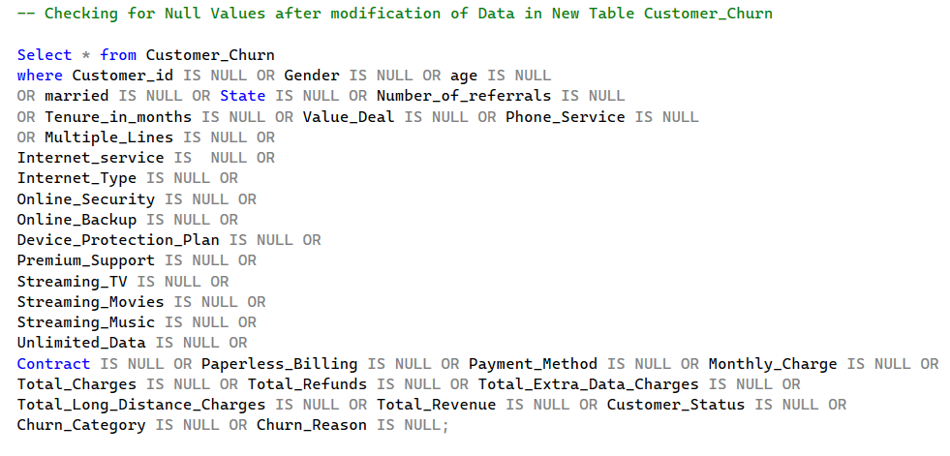

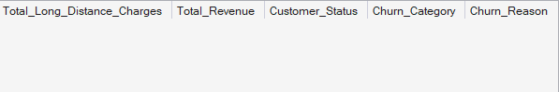

Business Problems-
- Find the total no. of customers.
- Find the number of customers who ‘Churned’.
- Find the number of customers who ‘joined’.
- Find the percentage of customers who ‘Churned’.
- Find the count and percentage of customers genderwise, who got ‘Churned’.
- Find Churn Rate by payment methods.
- Find total customers and churn rate as per age bucket.
- Find churn rate by ‘contract’.
- Find total customers and churn rate by tenure bucket.
- Find churn rate statewise for top 5 states in churn rate.
- Find churn rate and churn count by internet type.
- Find total churn and churn rate by churn category.
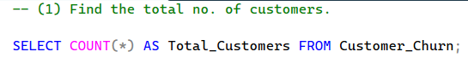

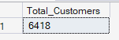

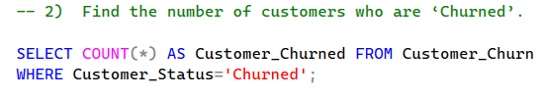

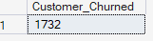

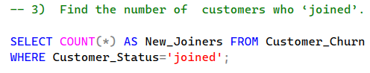

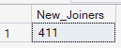

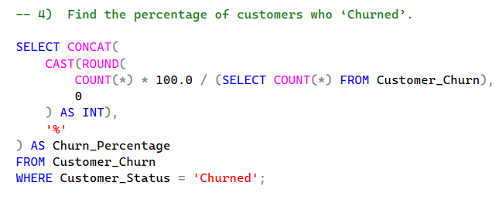

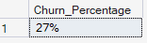

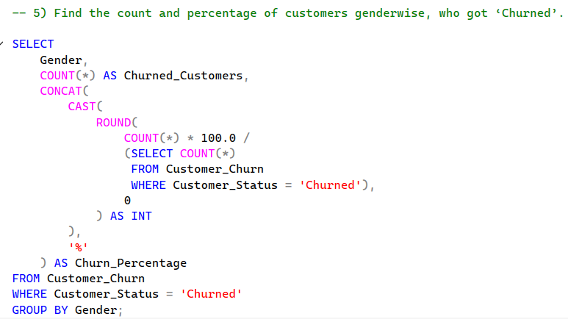

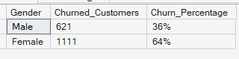

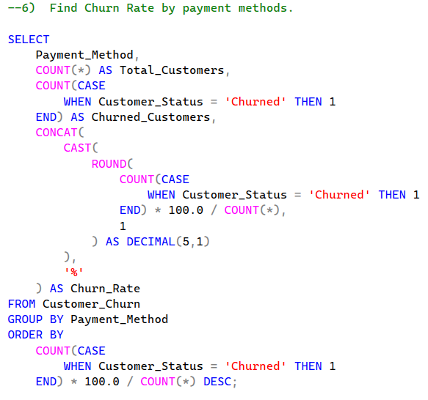

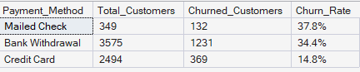

7) Find Total customers and churn rate as per age bucket.
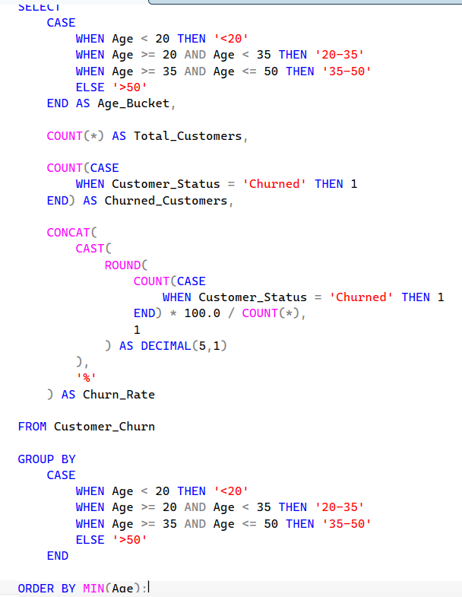

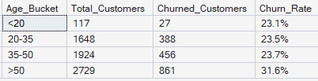

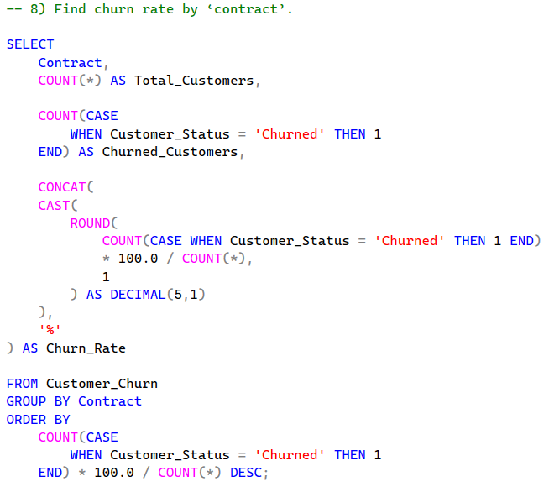

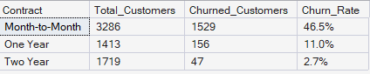

- Find total customers and churn rate by tenure bucket.

